**Conditional probability of letters (a first-order Markov information source)**

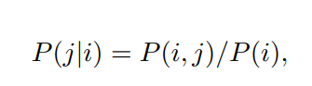

**Measure of information (I)**



**Shannon’s Entropy**

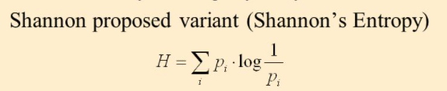

**Bits/nits/trits/dits**

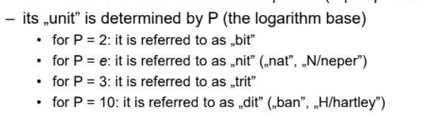

**Entropy formula**

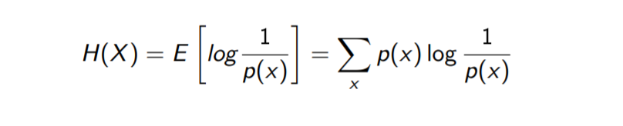

**Cross-entropy formula**

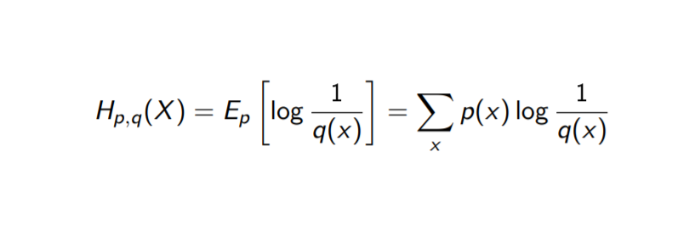

**Mutual information formula**

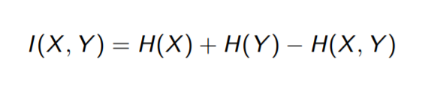

**Visualization of entropy**

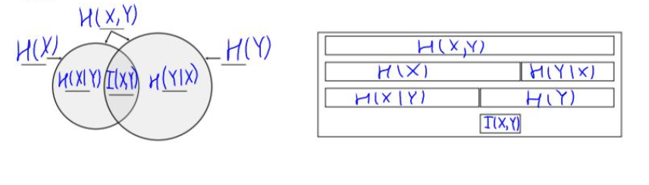

**Conditional entropy**

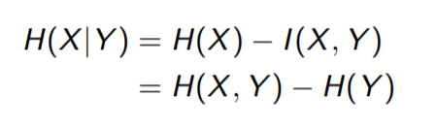

**(another notation)**

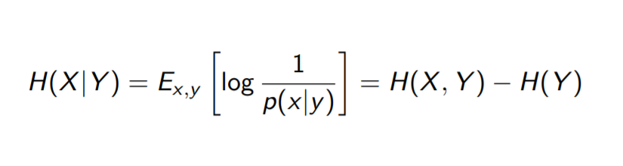

**Sigmoid function for Multi-label problem**

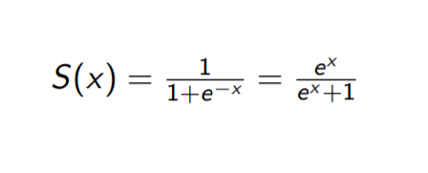

**Softmax function for Multi-class problem**

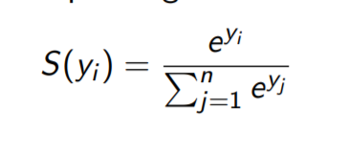

**Cross-entropy loss**

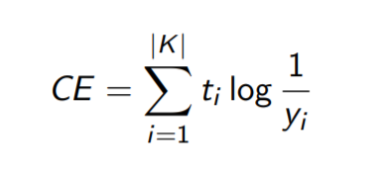

**Binary cross-entropy**

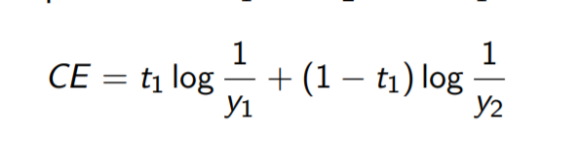

**Kullback-Leibler divergence (relative entropy)**

